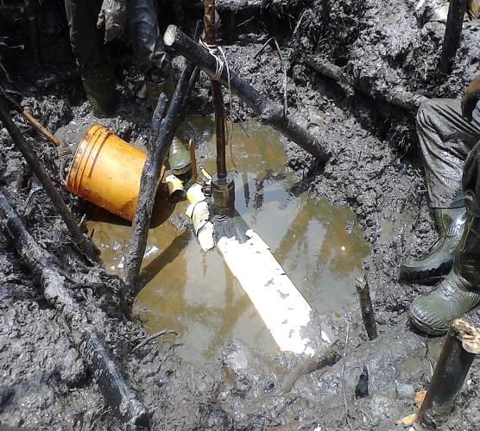 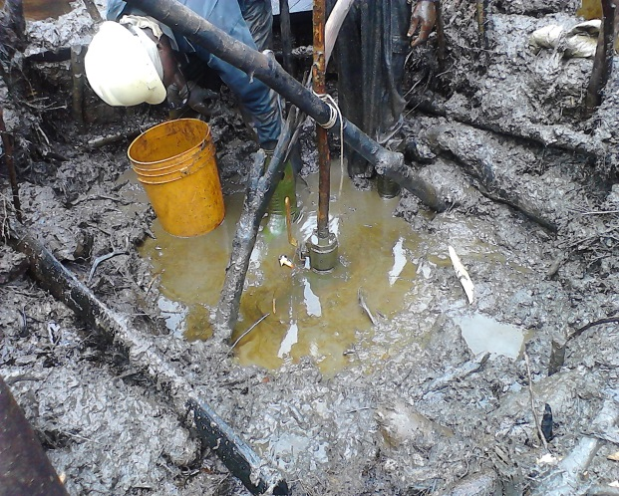 Fig. 1a 3’’ Valve & Nipple Installed Fig.1b Installed Valve @ 12 O’clock Position
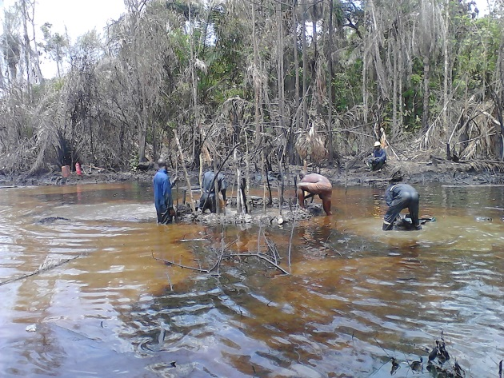 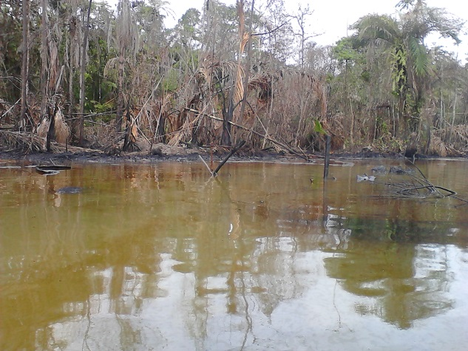 Fig. 2a ROW Heavily Saturated with Crude Oil Fig. 2b Creek Saturated with Oil
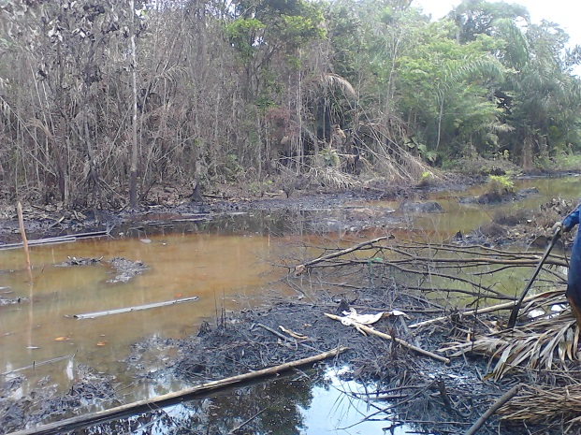 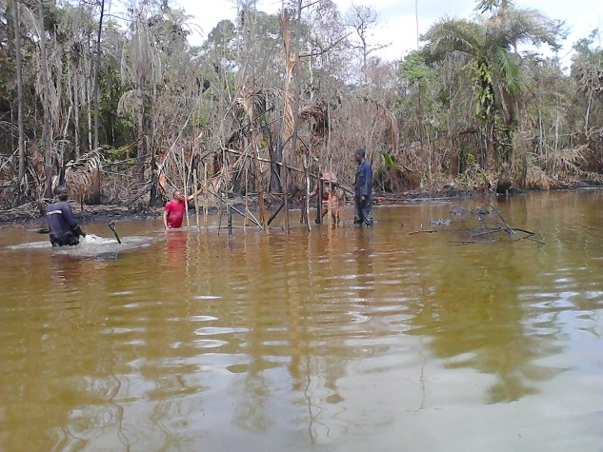 Fig. 3a Vegetation - Mixed Population Fig. 3b Vegetation Impacted
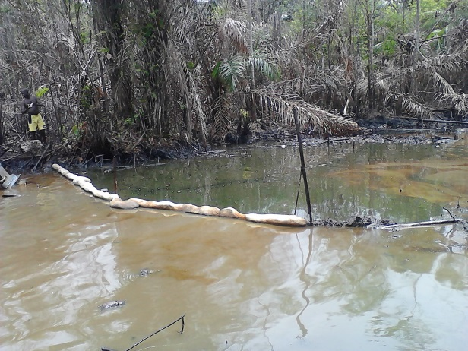 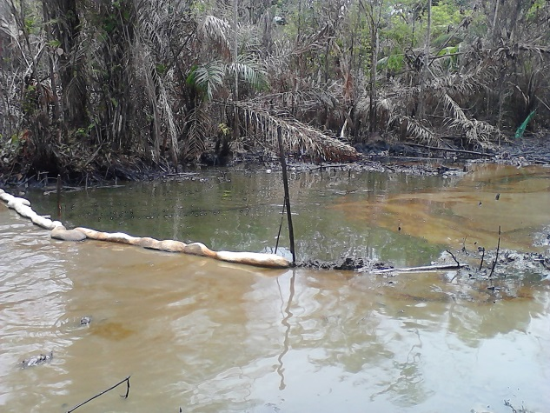 Fig. 4a Containment Booms around Spill Point Fig. 4b Contained Crude unrecovered.

